ASSIGNMENT – 4
1. In an HTML page-
o Use 3 different heading tags to write HTML, CSS, and JavaScript. Use a suitable
display property to display them on the same line.
o Use 3 different <span> tags to write JSP, JDBC, and MySQL. Use a suitable
display property to display them in separate lines.
HTML
<html>
<head>
<title>Q1</title>
<style>
h1,h2,h3 {
display: inline-block;
margin-right: 20px;
}
</style>
</head>
<body>
<h1> HTML </h1>
<h2> CSS </h2>
<h3> JS </h3>
<br>
<span>JSP</span><br>
<span>JDBC</span><br>
<span>MySQL</span><br>
</body>
</html>
Output:-
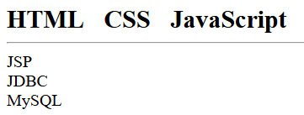

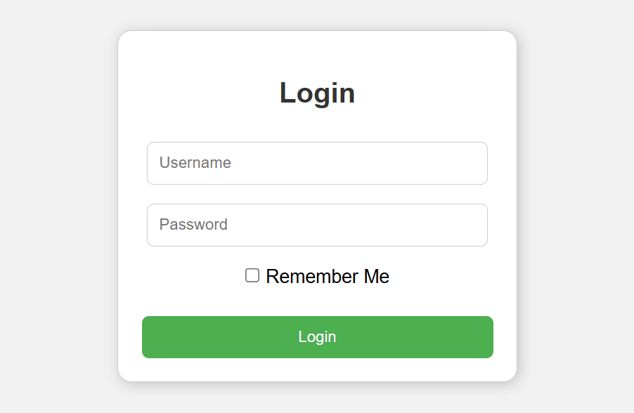
2. Design the following login form inside a styled card. Centre align the card with the help of flex box.

HTML
<!DOCTYPE html>
<html>
<head>
<title>Login</title>
<link rel="stylesheet" href="Style.css">
</head>
<body>
<div class="login-container">
<h2>Login</h2>
<form>
<div class="input-group">
<input type="text" placeholder="Username" required>
</div>
<div class="input-group">
<input type="password" placeholder="Password" required>
</div>
<div class="remember">
<input type="checkbox" id="remember">
<label for="remember">Remember Me</label>
</div>
<button type="submit">Login</button>
</form>
</div>
</body>
</html>
CSS
* {
margin: 0;
padding: 0;
box-sizing: border-box;
font-family: Arial, sans-serif;
}
body {
height: 100vh;
display: flex;
justify-content: center;
align-items: center;
background-color: #f2f2f2;
}
.login-container {
width: 380px;
padding: 40px;
background: white;
border-radius: 12px;
box-shadow: 0 8px 20px rgba(0, 0, 0, 0.1);
text-align: center;
}
.login-container h2 {
margin-bottom: 30px;
font-size: 28px;
color: #333;
}
.input-group {
margin-bottom: 20px;
}
.input-group input {
width: 100%;
padding: 12px;
border: 1px solid #ccc;
border-radius: 8px;
font-size: 14px;
outline: none;
}
.input-group input:focus {
border-color: #4CAF50;
}
.remember {
margin-bottom: 25px;
text-align: center;
font-size: 14px;
color: #333;
}
.remember input {
margin-right: 6px;
}
button {
width: 100%;
padding: 12px;
background-color: #4CAF50;
border: none;
border-radius: 8px;
color: white;
font-size: 16px;
cursor: pointer;
}
button:hover {
background-color: #43a047;
}
Output:-
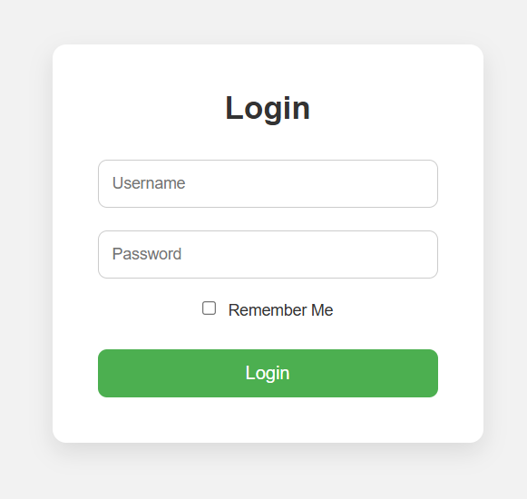

3. Design a Product Section for an eCommerce webpage using Flexbox. Create a container <div> with the title “Featured Products” . Inside the container, add 4 product cards in a single row. Each product card must include: Product image, Product name (heading), Price (paragraph), “Add to Cart” button
Q3.html
<html>
<head>
<title>Product Section</title>
<style>
body {
font-family: sans-serif;
background-color: Snow;
padding: 20px;
}
.container {
max-width: 1200px;
margin: auto;
text-align: center;
}
h1 { color: DarkSlateGray; margin-bottom: 30px; }
.product-grid {
display: flex;
justify-content: space-between;
gap: 20px;
}
.product-card {
background-color: White;
border: 1px solid LightGray;
border-radius: 10px;
padding: 15px;
flex: 1;
box-shadow: 2px 2px 10px Silver;
}
.product-card img {
width: 100%;
height: 150px;
background-color: LightSteelBlue;
border-radius: 5px;
object-fit: cover;
transition: transform 0.3s ease-in-out;
}
.product-card img:hover {
transform: translateY(-20px);
}
.product-card h3 {
font-size: 18px;
color: Black;
margin: 15px 0 10px;
}
.product-card p {
color: DimGray;
font-weight: bold;
margin-bottom: 15px;
}
.add-btn {
background-color: #45a049;
color: White;
border: none;
padding: 10px 15px;
border-radius: 5px;
cursor: pointer;
width: 100%;
font-weight: bold;
}
button:hover {
background-color: OrangeRed;
}
</style>
</head>
<body>
<div class="container">
<h1>Featured Products</h1>
<div class="product-grid">
<div class="product-card">
<img src="C:\Users\SILICON\Documents\24BCSH03\Assignment 4\s25U.jpg" alt="Product 1">
<h3>Samsung S25 Ultra</h3>
<p>$150000</p>
<button class="add-btn">Add to Cart</button>
</div>
<div class="product-card">
<img src="C:\Users\SILICON\Documents\24BCSH03\Assignment 4\17P.jpg" alt="Product 2">
<h3>Iphone 17 Pro Max</h3>
<p>$100000</p>
<button class="add-btn">Add to Cart</button>
</div>
<div class="product-card">
<img src="C:\Users\SILICON\Documents\24BCSH03\Assignment 4\OP15.jpg" alt="Product 3">
<h3>OnePlus 15</h3>
<p>$75000</p>
<button class="add-btn">Add to Cart</button>
</div>
<div class="product-card">
<img src="C:\Users\SILICON\Documents\24BCSH03\Assignment 4\IQ15.jpg" alt="Product 4">
<h3>IQOO 15</h3>
<p>$70000</p>
<button class="add-btn">Add to Cart</button>
</div>
</div>
</div>

</body>
</html>
Output:-
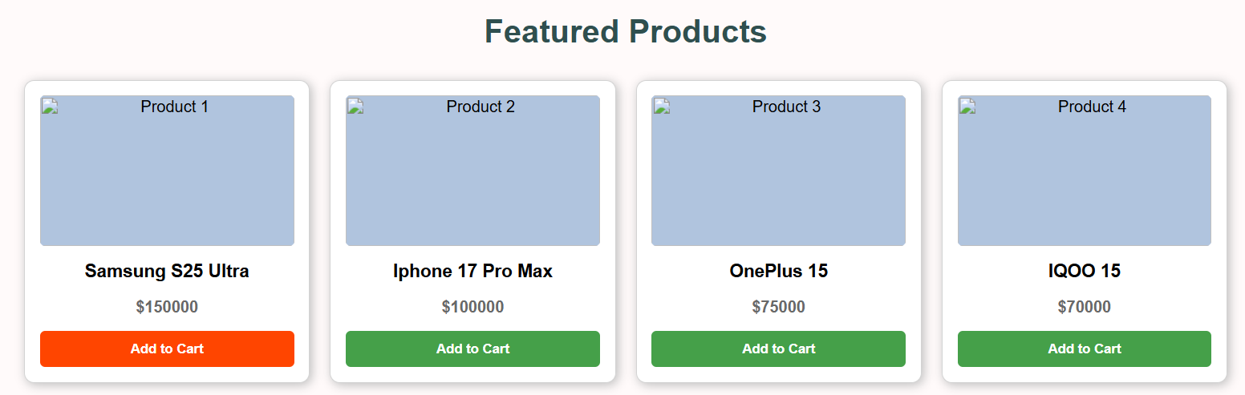
4. Enhance the “My Profile” page created in Assignment 2 to build a Personal Portfolio Website.
Q4.HTML
<html>
<head>
<title>John Doe | Portfolio</title>
<link rel="stylesheet" href="q4.css">
</head>
<body>
<header class="hero">
<div class="container">
<img src="hitler.jpg" alt="John Doe" class="profile-img">
<h1 class="name">John Doe</h1>
<p class="tagline">Full Stack Developer & UI Designer</p>
<p class="bio">Building digital experiences with precision and passion.</p>
<div class="cta-buttons">
<a href="mailto:john.doe@example.com" class="btn primary">Hire Me</a>
<a href="#projects" class="btn secondary">View Work</a>
</div>
</div>
</header>
<section id="projects" class="section">
<div class="container">
<h2 class="section-title">Featured Projects</h2>
<div class="projects-grid">
<div class="project-card">
<div class="project-info">
<h3>E-Commerce Platform</h3>
<p>A full-featured shop built with React and Node.js.</p>
<span class="tech-stack">React • Firebase</span><div class="project- action"><button> <ahref="file:///C:/Users/SILICON/Documents/24BCSH03/Assignment%204/Q3.html"target="_blank"class="project-btn">View Demo</a></button>
</div>
</div>
</div>
<div class="project-card">
<div class="project-info">
<h3>Portfolio Template</h3>
<p>A responsive HTML/CSS template for creatives.</p>
<span class="tech-stack">HTML • CSS • JS</span>
<div class="project-action">
<a href="<div class="project-action"> <button> <a href="file:///C:/Users/SILICON/Documents/24BCSH03/Assignment%204/Q4.html"target="_blank"class="project-btn">View Demo</a></button>
</div>
</div>
</div>
</div>
</div>
</section>
<footer class="contact-footer">
<div class="container">
<p><i class="fas fa-envelope"></i> john.doe@example.com</p>
<p><i class="fas fa-phone"></i> +91-9876543210</p>
<div class="social-links">
<a href="https://github.com/Ronit-kumar-swain-07"><i class="fab fa-github"></i></a>
<a href="https://www.linkedin.com/in/ronit-kumar-swain-3b94a3303/"><i class="fab fa-linkedin"></i></a>
</div>
</div>
</footer>
</body>
</html>
Q4.CSS
* { box-sizing: border-box; }
body {
margin: 0;
font-family: 'Poppins', sans-serif;
background-color: #f8f9fa;
color: #333;
line-height: 1.6;
}
.container { width: 90%; max-width: 1000px; margin: auto; }
.hero {
background: linear-gradient(135deg, #1a1a1a 0%, #2d3436 100%);
color: white;
padding: 80px 0;
text-align: center;
}
.profile-img {
width: 150px;
height: 150px;
border-radius: 50%;
border: 5px solid #4CAF50;
margin-bottom: 20px;
transition: transform 0.3s ease;
}
.profile-img:hover { transform: scale(1.05); }
.tagline { font-size: 1.2rem; color: #4CAF50; font-weight: 600; margin-top: 0; }
.btn {
padding: 10px 25px;
text-decoration: none;
border-radius: 25px;
margin: 10px;
display: inline-block;
transition: 0.3s;
}
.btn:hover {
background-color: GREEN;
}
.primary { background: #4CAF50; color: white; }
.secondary { border: 2px solid #4CAF50; color: #4CAF50; }
.primary:hover { background: #45a049; }
.section { padding: 60px 0; }
.section-title { text-align: center; margin-bottom: 40px; font-size: 2rem; }
.projects-grid {
display: grid;
grid-template-columns: repeat(auto-fit, minmax(300px, 1fr));
gap: 25px;
}
.project-card {
background: white;
padding: 20px;
border-radius: 15px;
box-shadow: 0 4px 15px rgba(0,0,0,0.05);
border-bottom: 4px solid #4CAF50;
}
.tech-stack { font-size: 0.8rem; color: #4CAF50; font-weight: bold; }
.contact-footer {
background: #1a1a1a;
color: #999;
padding: 40px 0;
text-align: center;
}
.social-links a { color: white; font-size: 1.5rem; margin: 0 10px; }
Output :-
